**ASDM ASSIGNMENT 4**

Q1. Implement hotel management system through Use case Diagram.

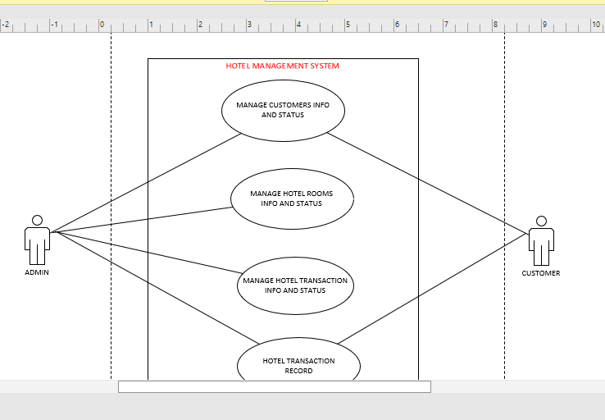

Q2. Design the Sequence diagram for ATM System taking into consideration different scenarios.

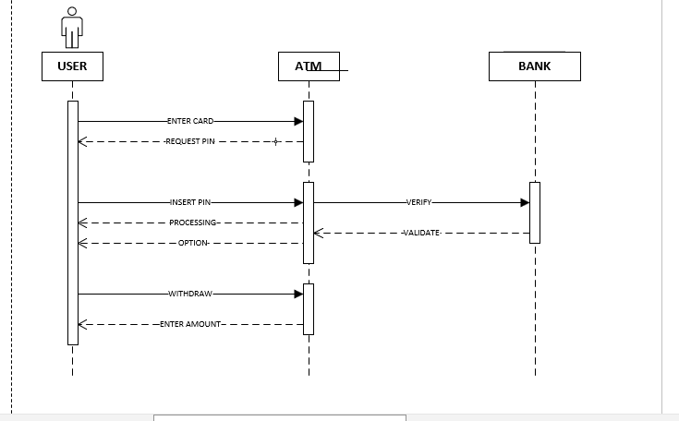

Q3. Design the class diagram for online food ordering system.

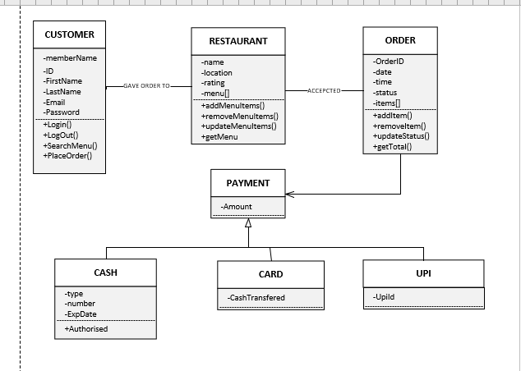

Q4. Design the activity diagram for student Attendance management system

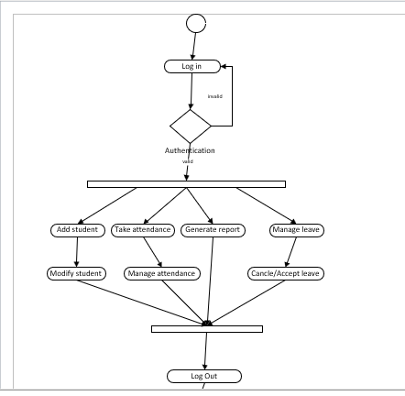

Q5. Identify the design principle that is being violated in relation to the given scenario.

|  |  |  |
| --- | --- | --- |
| **NO** | **Description** | **Principle Being violated** |
| 1 | Important information of a module is directly accessible by other modules | Violation of Encapsulation |
| 2 | Too many global variables in the program after implementing the design | Violation of Encapsulation |
| 3 | Code breaks in unexpected places | Violation of Decomposition and Modularization |
| 4 | Unfulfilled requirements in the code after the design has been implemented | Violation of Abstraction |
| 5 | cyclic dependency among classes | Violation of Coupling & Cohesion |
| 6 | Huge class doing too many operations unrelated | Violation of Sufficiency, Completeness and Primitiveness |
| 7 | Several un-related functionalities/tasks are carried out by a single module | Violation of Decomposition and Modularization |
| 8 | All data of all classes in public | Violation of Encapsulation |
| 9 | Design resulting in spaghetti code | Violation of Decomposition and Modularization |
| 10 | An algorithm documented as part of design is not understandable by the programmers | Violation of Abstraction |